MAC Board Report, October 5, 2109

New MAC/MLA Logo
The updated MACMLA logo is in place on the MAC website, was added to PBWorks forms and letterhead, Wild Apricot, and adjusted for the MAC Messages blog. A new MAC promotional brochure was created with updated images and content (see appendix).

MAC Annual Meeting Communication Plan

This document was updated from the 2016 version. It is a detailed plan that sets clear goals and expectations about who is responsible for promoting the conference and surrounding events to organizations, schools, and associations outside of the MAC membership. Working with the Annual Meeting Committee, volunteers took over specific targeted groups and forwarded MAC blog messages to them as requested. We recommend that this document be updated annually and used for successive annual conferences (see appendix).

MAC Messages
The Communications Committee worked on several issues regarding the MAC Messages blog. There is a User List and an Email Subscribers List. The Users List is all of our current MAC members. Everly consulted with former blog coordinator, Sarah Wade and WordPress, to understand the issue.
Sarah stated, “Previously on the website we had a widget that allowed people to sign up for the blog and that is where the Email Subscribers List came from. The widget was run through the Email Subscribers plugin. They are all people who subscribed to our blog at some point in the past. That widget is no longer active so we are not currently adding any members to that list. I went through and compared the list and out of the 268 members on the Users List only 148 of them are also on the Email Subscribers List.“ Do we need to remove the Email List?

Other Issues
Yunting Fu, from the University of Maryland, Baltimore has agreed to be Chair-Designate.
The Communications Committee folder in PBWorks was cleaned up. There is now a folder for each year containing the year’s work.
The Communications Committee is currently out of compliance with the recommendation in MAC’s Policy & Procedures Manual that membership be composed of a mix of hospital, academic, and special librarians representing each state in the chapter. We do have one student member this year and one member from NLM. With several members completing their terms in 2019, the committee chair and chair‐designate will need to strategize on how to recruit new members that will help us meet our goals of balanced representation

Appendix: MAC Promotional Brochure

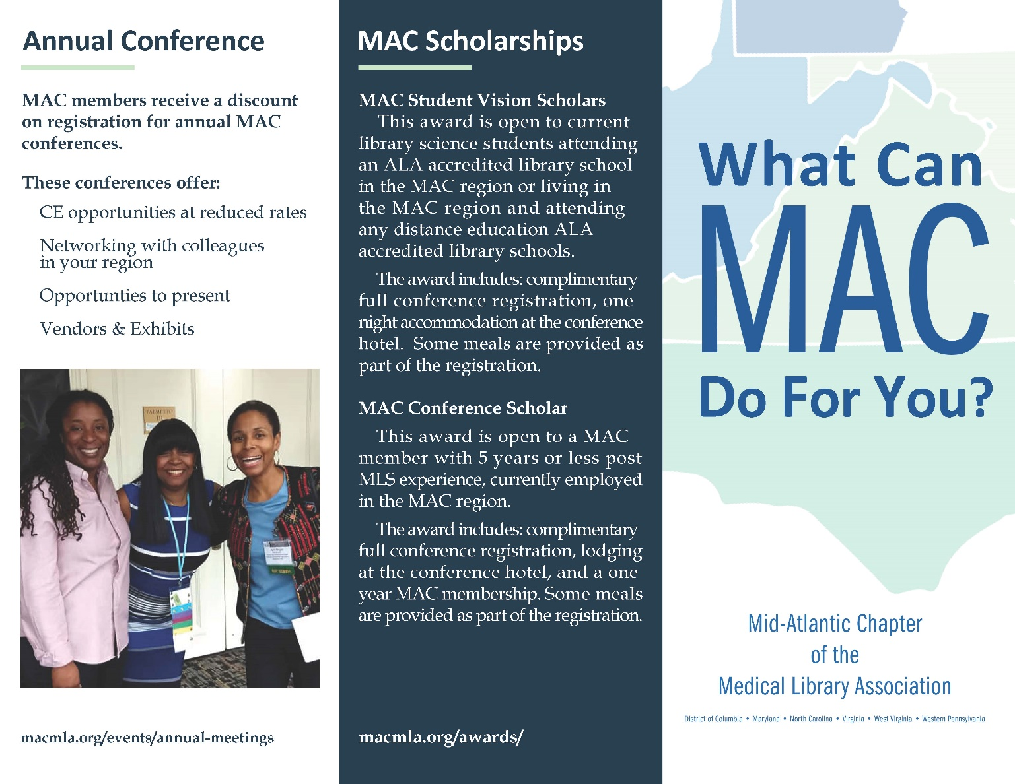

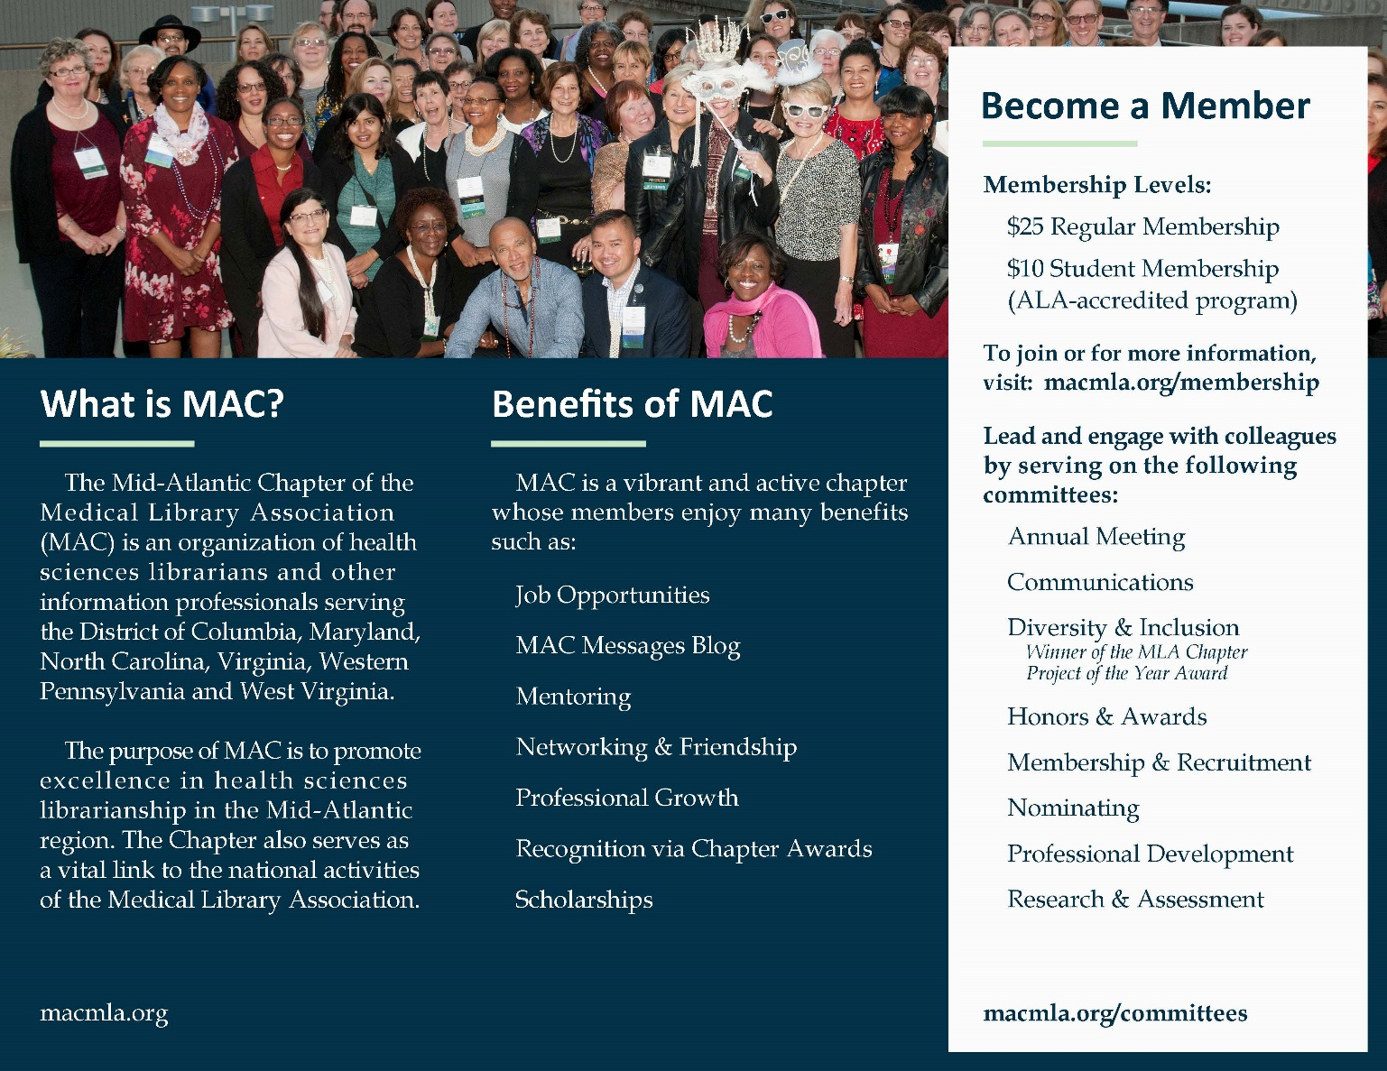

Appendix: MAC Annual Meeting Communication Plan

